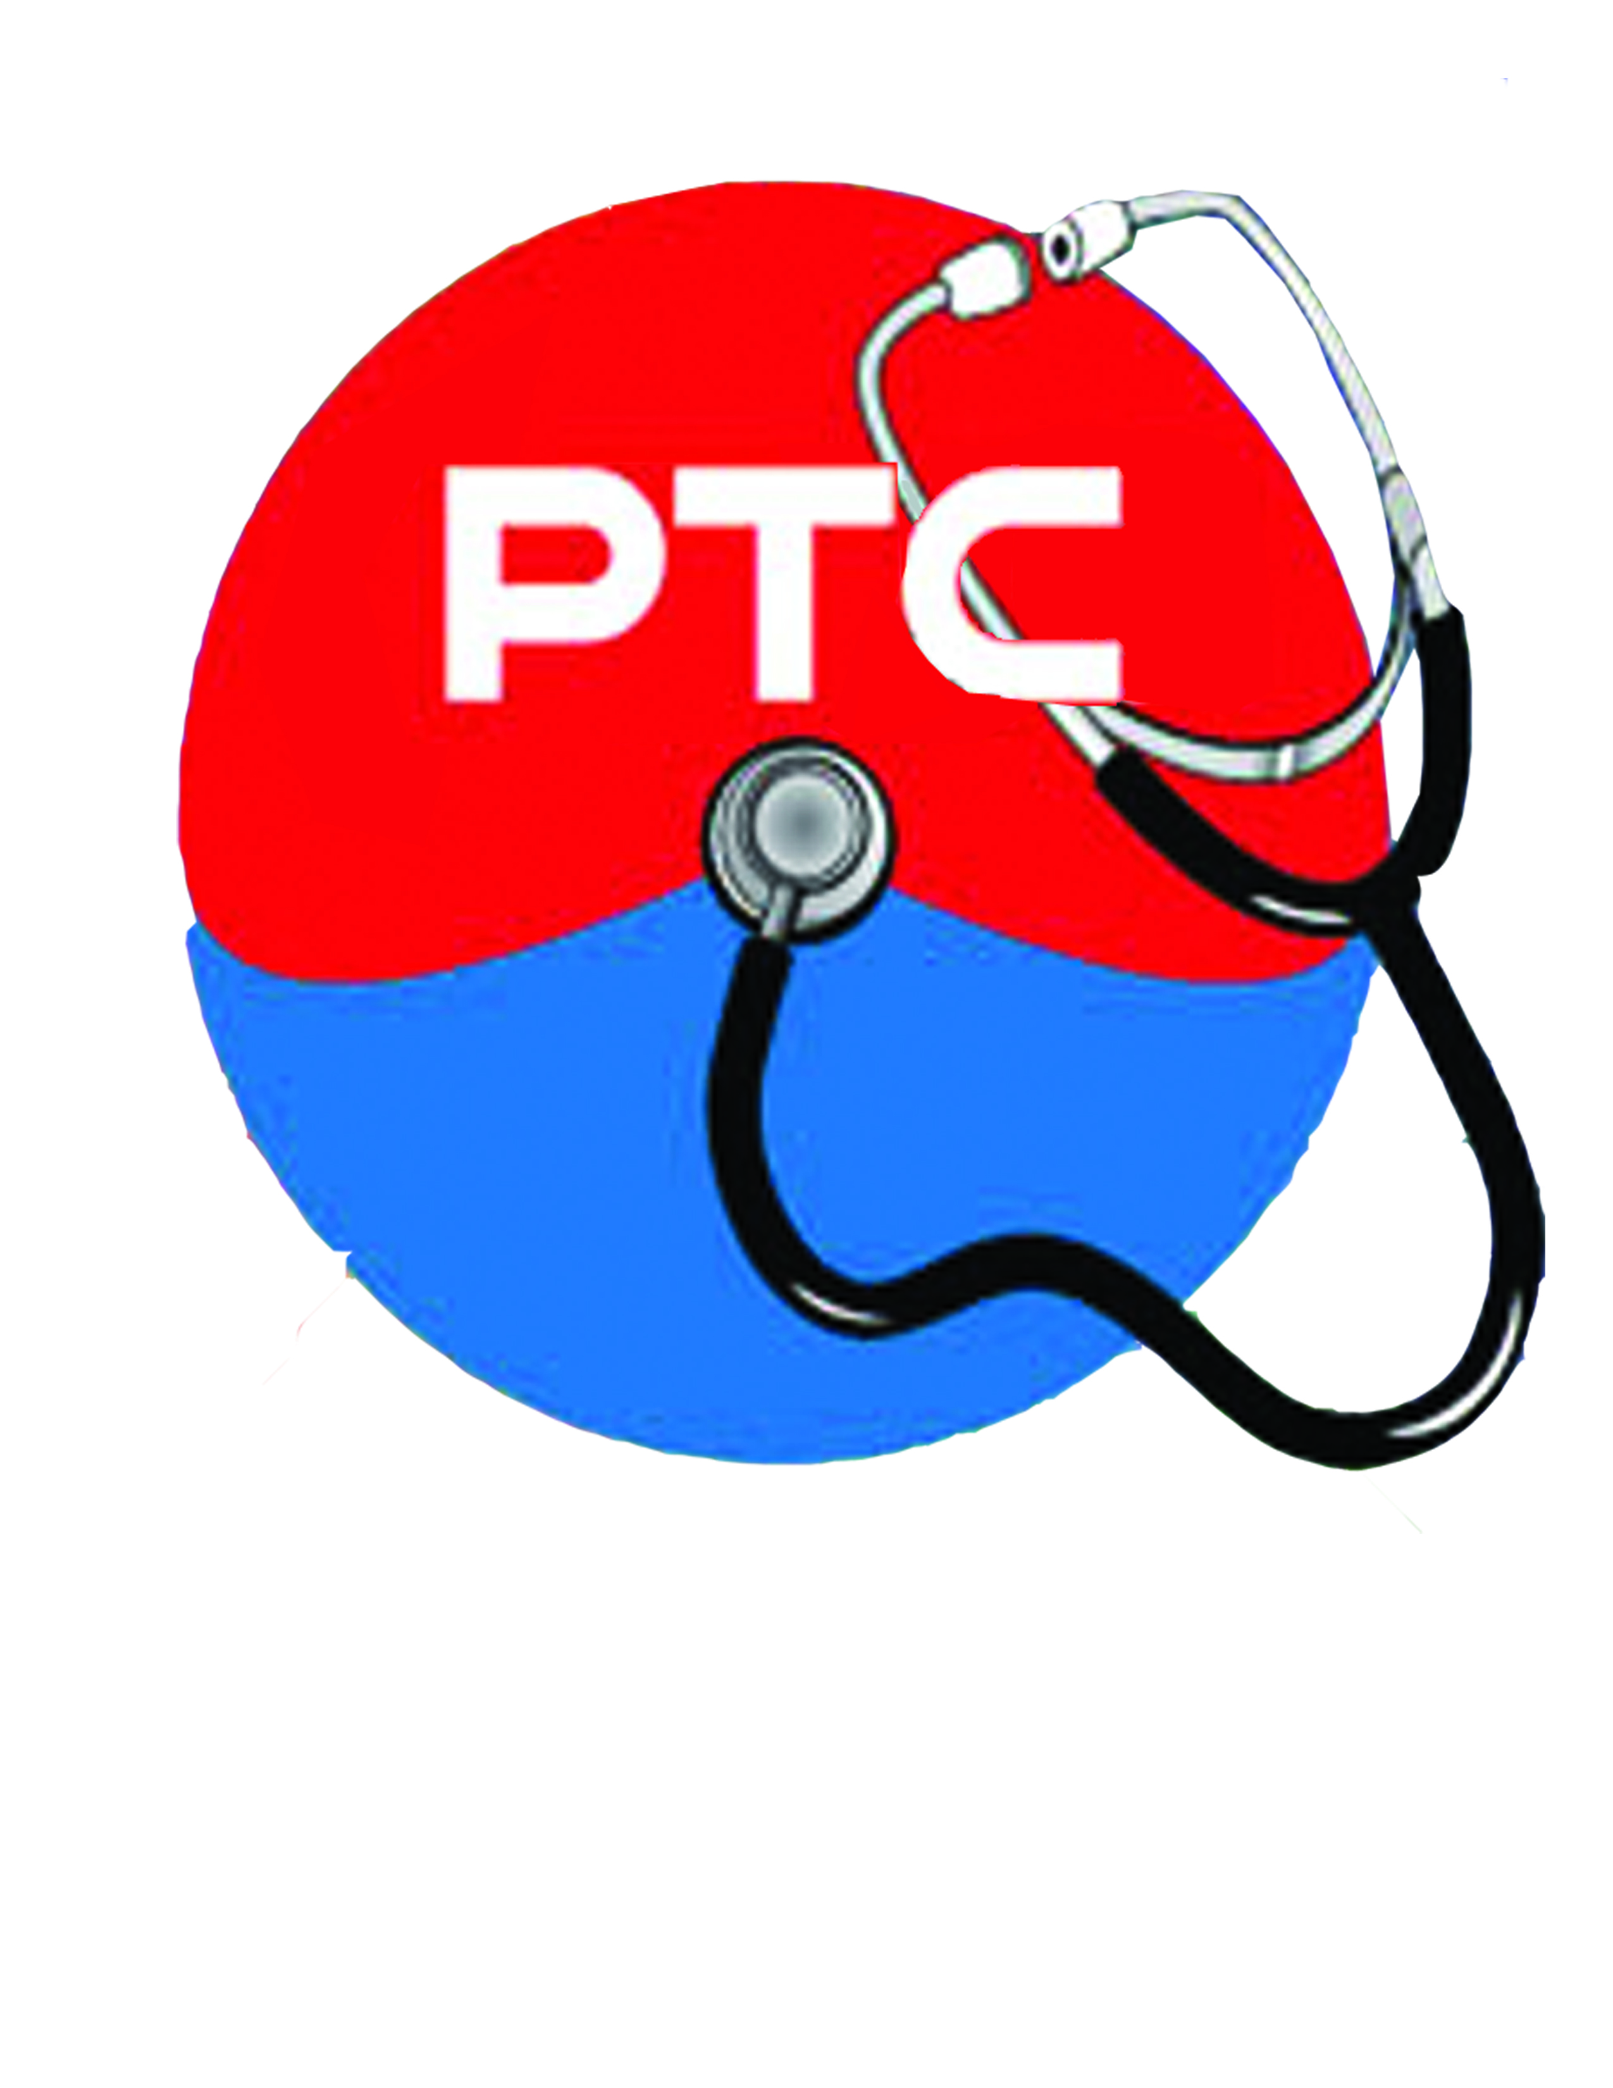

**MAIN CAMPUS:**

90 W. Grand Blvd. Suite 107

Corona, CA 92882

Office Phone: (951) 734-1601

Fax: (951) 734-1602

**BRANCH:**

14340 Elsworth St. Suite B108

Moreno Valley, CA 92553

Office Phone: (951) 656-4400

Fax: (951) 656-4402

**WEBSITES:**

www.pthcedu.com

www.pthealthcarepros.com

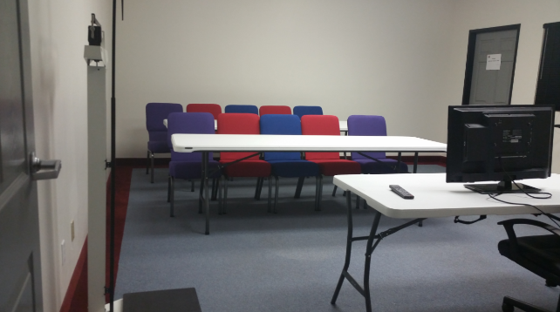

***PACIFIC TIMES HEALTHCARE COLLEGE***

***“Success occurs when opportunity meets preparation!”***

***-*** ***Zig Ziglar***

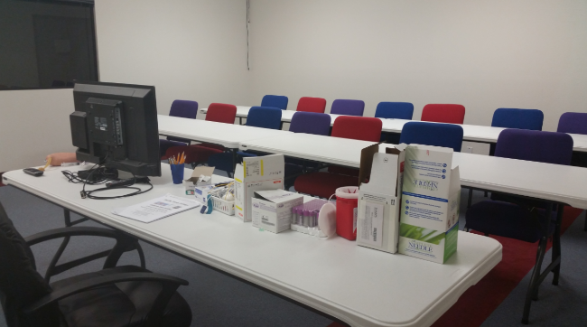



**NOW ENROLLING Nurse Assistant Training**

**and**

**Patient Care Technician, and MORE!**

**Visit us online or call today!!**



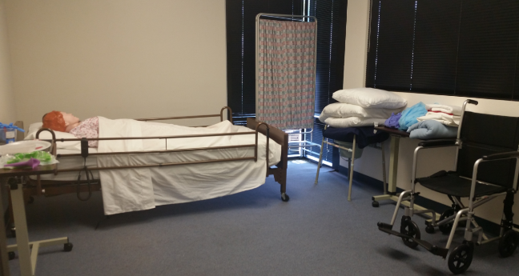



www.pthcedu.com

A smiling person and person posing for a photo

Description generated with very high confidence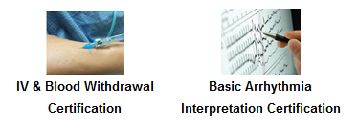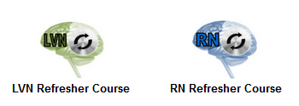

PTHC COLLEGE MISSION STATEMENT

PTHC College was established to provide quality affordable education to a diverse population interested in pursuing a career in the healthcare field. PTHC College continues to enhance its role in vocational and technical education by developing and improving a variety of intellectual and challenging training programs that are highly in demand. The administration, staff and faculty work together to provide its community with theoretical and practical skills required in today’s complex healthcare job market.

PTHC Objective

The objective of PTHC College is institutional stability as the foundation for a positive learning environment through providing quality education. The training outcomes have been proven to be preparation for employment through the development of entry-level skills in an identified demand occupation and student’s skills equal to or greater than industry standards, enhancement of skills for career /professional development, and life-long preparation. At PTHC the course curriculum is reviewed, not less than annually, for consistency with skills required in the workplace, with continuous improvement through the application of quality organizational techniques and the use of a standard based on an Institutional Development Plan.

www.pthcedu.com

**PACIFIC TIMES HEALTHCARE COLLEGE**

**Nurse Assistant instructors are all approved by the California Department of Public Health.**

**Check us out on CDPH’s Website!**

***COURSES @ PTHC:***

* **Nurse Assistant Training Weekday**
* **Nurse Assistant Training Weekend**
* **Patient Care Technician Training Weekday**
* **Patient Care Technician Training Weekend**
* **Basic Arrhythmia Recognition**
* **Ventilator Management**
* **Tracheostomy Care Certification**
* **Director of Staff Development**
* **RN Refresher**
* **LVN Refresher**
* **IV and Blood Withdrawal**
* **Continuous Education Classes**
* **American Heart Association Classes**